Case Study:
Easylube 250 RFID for Semiconductor Industry - Application: Stamping Machine
Customer Background - Market Leader in Frame Manufacturing
Problem Encountered
- Bearing breakdown averaging 2-3 times a year
- Minimum 3 day repair - high breakdown costs
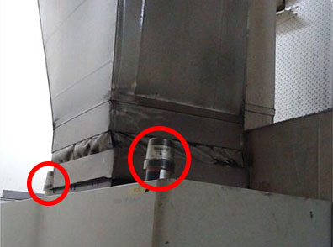
Results:

- Saved 81% on the first year and 98% on subsequent years on repairs costs
- Simplified maintenance and lubrication procedure, no re-lubrication work required
- Enhanced visual inspection for maintenance personnel to monitor each bearing’s condition
- Reduced maintenance and service costs

