Case Study:

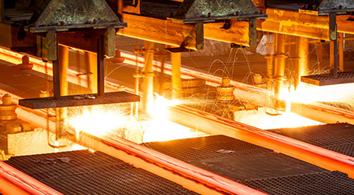
- Saved 74% on total maintenance costs.
- Bearing performance and lifespan have been maximized thus productivity has been increased.
- Better visual inspection for maintenance personnel to monitor each bearing condition through Easylube’s indication light.
- Reduced in breakdown thus cut down operating and maintenance costs.
Easylube 150 RFID for Steel Mills
Application: Indirect system cooling tower – motor
Customer Background
Steel Maker in Malaysia
Problem Encountered
Operating hours: 24 hours/7 days
Operating conditions: Heated / Dusty
Previous greasing method: Manual grease gun
Greasing interval: 3 months
- Hard to do greasing as the direct system cooling tower’s motor is located at isolated area thus missed-lube is unavoidable
- Inefficient lubrication causes motor bearings worn off more than desired. It took at least 2 days to complete the repair work
Improvement Needed
- Reduce maintenance and downtime costs
- Prolong bearings life
Results
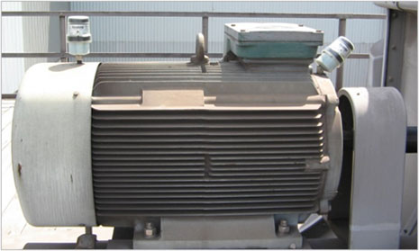
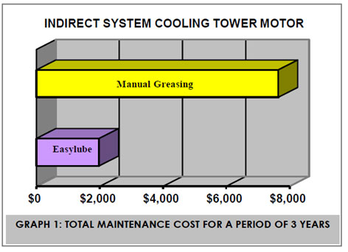

After using Easylube single-point microcomputer grease lubricating system for 3 years:
- Save 74% on total maintenance costs (Graph 1)
- Bearing performance and lifespan have been maximized thus productivity has been increased.
- Better visual inspection for maintenance personnel to monitor each bearing condition through Easylube’s indication light.
- Reduced in breakdown thus cut down operating and maintenance costs.

