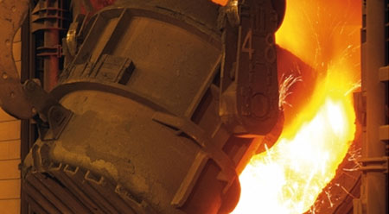

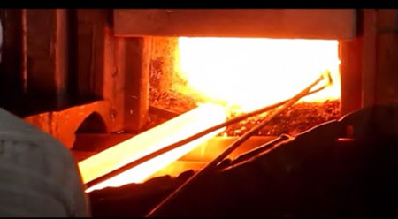
Case Study – Steel Mill Melt Shop – Cutting torch - Reduce workload, and simplify maintenance and lubrication procedures
Easylube 150 RFID
Operating issues:
Operating hours: 24 hours/7 days
Operating conditions: Heated / Dusty
Previous greasing method: Manual grease gun
Previous re-greasing interval: Unscheduled/during bearing change
Problems encountered:
- Bearing breakdown in every 5 to 6 months
- High breakdown, service and downtime costs
- Vibration due to frictional wear increased between ball and screw affected the quality of finished product
Improvement needed:
- To prolong bearings lifespan
- To simplify maintenance schedule and reduce work loads
- To reduce downtime services and maintenance costs
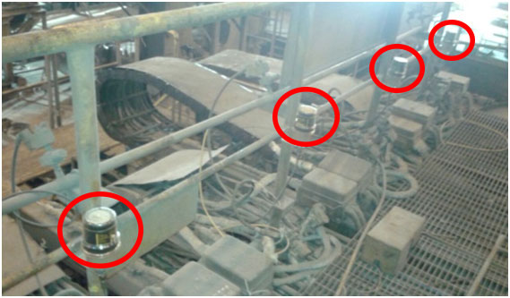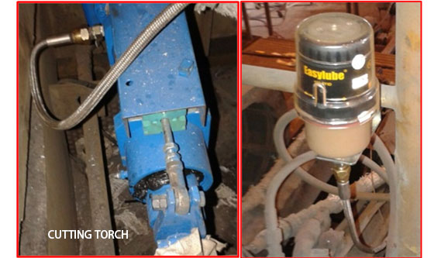
After using Easylube RFID single-point microcomputer grease lubricating system:
- Bearing life significantly extended
- Reduced workload and simplified maintenance and lubrication procedures
- Greatly reduced downtime and service and maintenance costs

