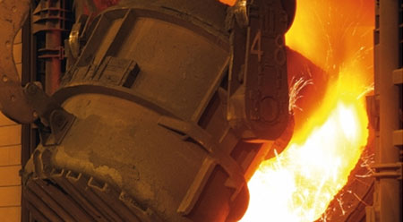

Easylube 150RFID for Steel Mills - Water Pump Motor Bearings
Energy savings of 13.1% for the first year, 13.5% for the following year.
Application: Direct Cooling Water Pump Motor (150kw) – Bearings

Customer Background
Steel Manufacturer

Problem Encountered
Operating hours: 21 hours/7 days
Operating conditions: Heated / Dusty
Previous greasing method: Manual grease gun
Previous re-greasing interval: Every 6 months
Problems encountered:
Due to high speed and long operating hours, the electric consumption (ampere reading) for motors are tremendously high. Under-lubrication has been a problem which caused high ampere reading.
When the bearing is under-lubricated, friction increased and this leads to energy loss and shortens motor lifespan. The motor bearing was found to be changed every 2 years and this problem creates unnecessary mechanical repairs, parts replacement, services and downtime costs.
Improvement Requirement:
- Prolong bearing lifespan
- Reduce electric consumption
- Reduce operating and maintenance costs

Results
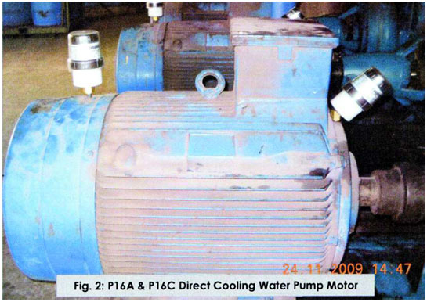
After using Easylube single-point microcomputer grease lubricating system at the Direct Cooling Water Pump Motor (150kw):
- Energy savings of 13.1% for the first year, and 13.5% for the following year
- Maximized the motor lifespan and performance
- Proven to be a better method of lubricating the bearings. It simplifies maintenance and lubrication schedule. No more manual re-greasing work is needed
- Reduced the risks of breakdown, and cut down operating and maintenance costs

